

Trabalho Prático

Armazenamento e Acesso a Dados

functions

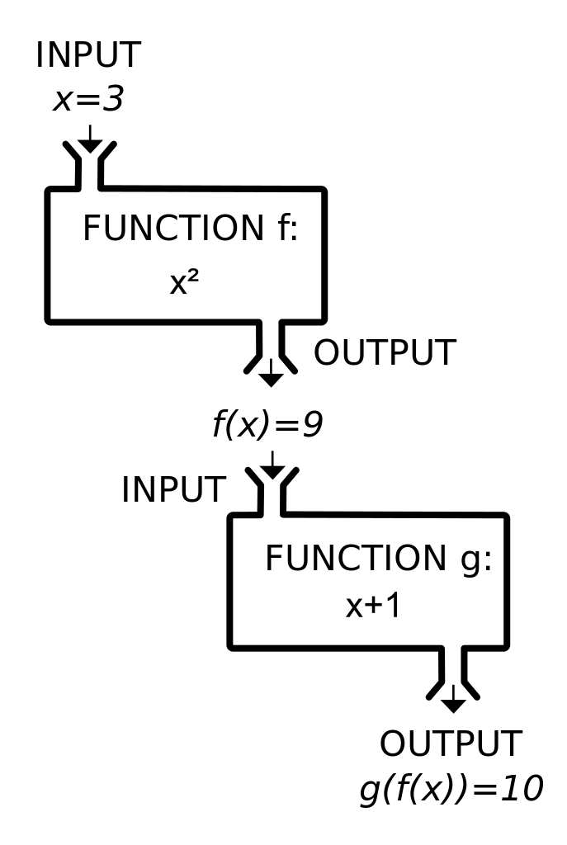

**Calcular Anos**

CREATE FUNCTION [dbo].[CalcularAnos]

(

@Data AS DATETIME

)

RETURNS INT

AS

BEGIN

DECLARE @Anos INT;

SET @Anos = ((CAST(CONVERT(VARCHAR(8),GETDATE(),112) AS INT)-(CAST(CONVERT(VARCHAR(8), @Data,112) AS INT)))/10000)

RETURN @Anos

END

**Tratar Nome**

ALTER FUNCTION [dbo].[TratarNome]

(

@Input VARCHAR(MAX),

@ToUpper BIT,

@ToProperCase BIT,

@RemoveDiacritics BIT

)

RETURNS VARCHAR(MAX)

AS

BEGIN

DECLARE @Output VARCHAR(MAX)

SET @Output = RTRIM(LTRIM(@Input));

IF (@ToUpper = 1 AND @Output != '')

BEGIN

SET @Output = (SELECT UPPER(@Output))

END

IF (@RemoveDiacritics = 1 AND @Output != '')

BEGIN

SET @Output = (SELECT @Output Collate SQL_Latin1_General_CP1253_CI_AI)

END

IF (@ToProperCase = 1 AND @Output != '')

BEGIN

DECLARE @Pos1 INT = 1

DECLARE @Pos2 INT

SET @Output = LOWER(@Output)

WHILE (1 = 1)

BEGIN

SET @Output = STUFF(@Output, @Pos1, 1, UPPER(SUBSTRING(@Output, @Pos1, 1)))

SET @Pos2 = PATINDEX('%[- ''.)(]%', SUBSTRING(@Output, @Pos1, 500))

SET @Pos1 += @Pos2

IF (ISNULL(@Pos2, 0) = 0 or @Pos1 > LEN(@Output))

BEGIN

BREAK

END

END

END

RETURN @Output

END

**Validar NIF**

ALTER FUNCTION [dbo].[ValidarNIF]

(

@NIF VARCHAR( 50)

)

RETURNS bit

AS

BEGIN

DECLARE @Output BIT;

SET @Output = 0 ;

IF(ISNUMERIC(@NIF) = 0)

BEGIN

SET @Output = 0

RETURN @Output

END

--Tem de ter 9 digitos e o digito inicial tem de ser 1,2,5,6,7,8,9

IF (@NIF < 100000000 OR @NIF > 999999999) OR (@NIF > 299999999 AND @NIF < 500000000)

BEGIN

SET @Output = 0

RETURN @Output

END

DECLARE @NifString VARCHAR( 9)

SET @NifString = CAST(@NIF AS VARCHAR(9 ))

DECLARE @Control INT

SET @Control = 9 * (cast(SUBSTRING(@NifString , 1, 1) AS INT)) + 8*(cast(SUBSTRING(@NifString , 2, 1) AS INT )) +

7 *(cast(SUBSTRING(@NifString , 3, 1) AS INT )) + 6*(CAST(SUBSTRING(@NifString , 4, 1) AS INT )) +

5 *(cast(SUBSTRING(@NifString , 5, 1) AS INT )) + 4*(CAST(SUBSTRING(@NifString , 6, 1) AS INT )) +

3 *(cast(SUBSTRING(@NifString , 7, 1) AS INT )) + 2*(CAST(SUBSTRING(@NifString , 8, 1) AS INT ))

DECLARE @Remainder INT

SET @Remainder = @Control % 11

IF @Remainder < 2

BEGIN

IF CAST(SUBSTRING(@NifString, 9 , 1) AS INT) = 0

BEGIN

SET @Output = 1

END

ELSE

BEGIN

SET @Output = 0

END

END

ELSE

BEGIN

IF (11 - @Remainder) = CAST(SUBSTRING(@NifString , 9, 1) AS INT)

BEGIN

SET @Output = 1

END

ELSE

BEGIN

SET @Output = 0

RETURN @Output

END

END

RETURN @Output

END